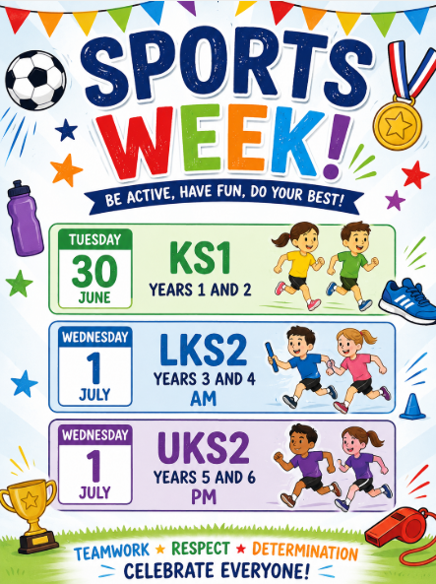
PM
13:30-15:00
13:30-15:00
9:30-11:00
Parents/Carers welcome!

