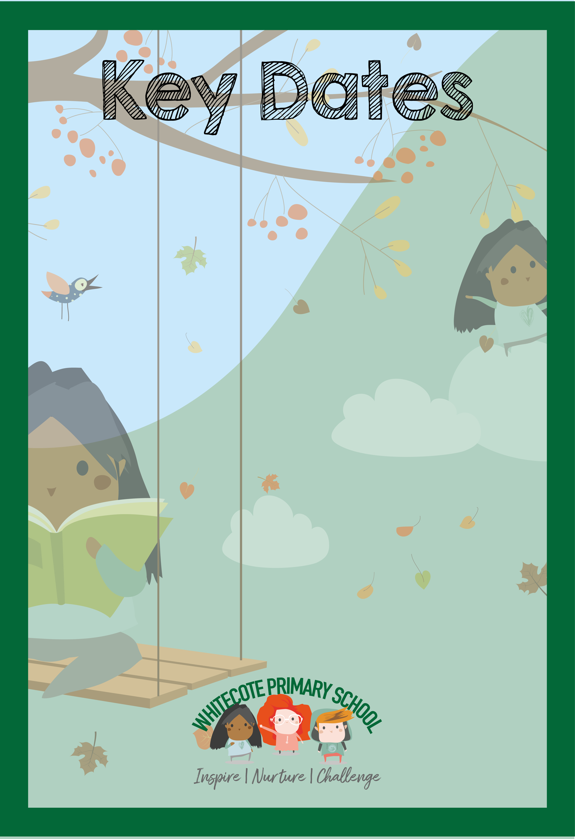
Autumn 1 2026 – Nursery dates

Monday 31st August – Bank Holiday
Tuesday 1st September – training day
Wednesday 2nd September-school re-opens

Week beginning Monday 21st September
Making pizza faces

Wednesday 30th September am and pm sessions
Birthday party for the Nursery Bears

Wednesday 14th October – 9-9:45am and 2:15-3pm Stay and play

Wednesday 21st October 10:50am or 2:20pm Pumpkin Trail (parents and carers invited)

Thursday 22nd and Friday 23rd October – Training Days

Monday 26th - Friday 30th October- half-term holiday

