Whitecote Primary School Packed Lunch Policy

At Whitecote Primary School, we want everyone to be able to make healthy choices.

To help with this we have written a document called ‘Packed Lunch Policy’. This tells you and your parents and carers the best way to provide a healthy packed lunch for school. We expect all families to follow the policy as it will help you
- be fitter now and in later life
- learn more quickly
- behave better

Lunch time staff will monitor what children bring in their packed lunches and give you praise and stickers for your healthy choices. If the choices are not so healthy they will talk to you about it and also to your parents.

What you should have in your packed lunch
Following published policy, it is recommended that packed lunches contain one food from each of these groups every day:
A starchy food (such as brown bread, pasta, rice, noodles or potatoes). | 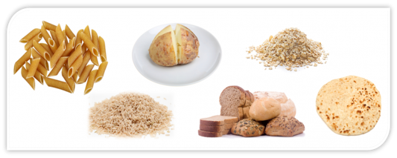
At least 1 portion of fruit and1 portion of vegetables. | 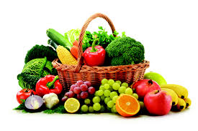
Meat, fish (e.g. a ham or tuna sandwich) or another source of non – dairy protein (such as lentils, hummus or kidney beans) | 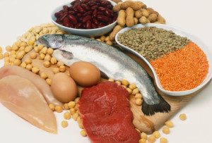
A dairy food (such as milk, cheese, yogurt, fromage frais or custard ) | 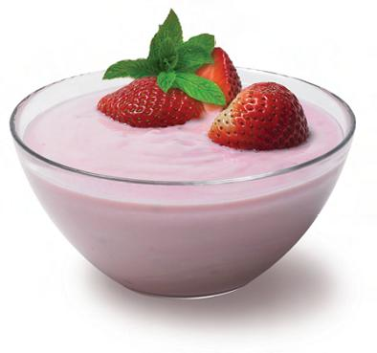
A drink of still water or unsweetened fruit juice | 

What you might have in your packed lunch occasionally
(about once every 2 or 3 weeks)

Oily fish, such as tuna and salmon | 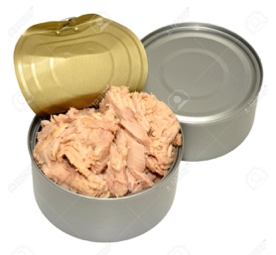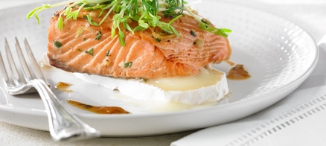
Meat products such as sausage rolls, pies, corned beef and chipolatas/sausages | 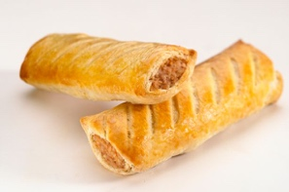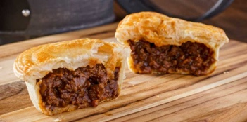

What you should NOT have in your packed lunch

Snacks such as crisps | 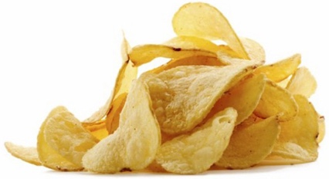
Confectionery such as chocolate bars and sweets. | 
Fizzy or sweetened drinks | 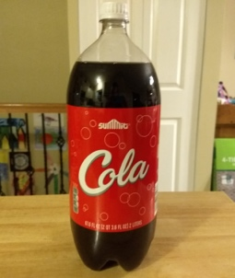
Nuts or nut products (Some are healthy but other people may have allergies to them) | 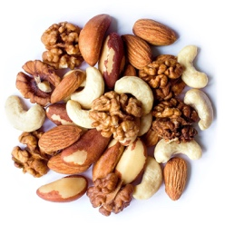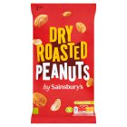

If you have a medical condition that means you need a special diet, staff at the school will need to know so that they can make sure you have the correct food.

Because your parents need to know what you are eating and to avoid allergic reactions, you are not allowed to swap food with friends.

Further information is available in the full document ‘Packed Lunch Policy’ on the School website.

