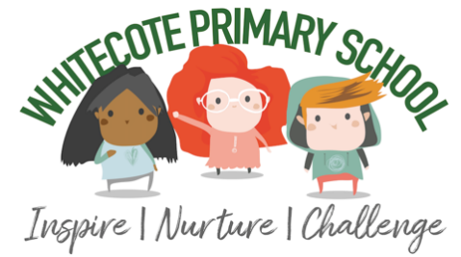
Whitecote Primary School

After School Club

Please note:

- After School Club Staff are not responsible for items lost or misplaced by your child.

- Please check your child has all of their belongings when you collect them.

- We do not have adequate staff numbers to escort you or your child to their classroom to look for missing items. Please contact your child’s teacher to discuss items left in class.

- If you write your child’s name in their clothing it is easier to identify and return.

- Please do not send your child to school in branded clothes for PE.

- While we appreciate it can be frustrating when items go missing, please be considerate with our staff when discussing your frustrations. School has a zero tolerance policy in place to protect staff.

Thank you for your understanding.

The Wrap Around Care Team

