 | Music
Topic: Music Technology
Year: Year 2
What I should already know |  | History of Music Technology | Vocabulary
 |  | 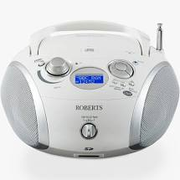  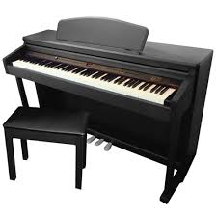    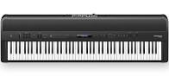  cd player  piano  streaming app  keyboard  Music technology is any technology that is used by a musician to help make music.  The piano (and its predecessor the harpsichord) was a technological innovation of its time (17th century).  In the twentieth century music started to be recorded so it could be listened to at home.  Recent music technology includes mp3s, tablets and streaming audio.
  To copy a simple rhythm and can differentiate between pulse and rhythm | To differentiate between high and low sounds and can show changes in pitch using tuned percussion e.g. steps, slides, jumps | To control changes in tempo with my body, and instruments, e.g. faster/slower
  To control changes in dynamics with my voice and instruments, e.g. louder/quieter | To choose and order sounds and patterns and use pictures to represent the sounds | To differentiate between long and short sounds and use them when composing, notating my patterns
  To choose sounds to represent ideas (eg shakers for leaves falling off a tree)
  Pulse/beat | The heartbeat or steady beat of a song/piece of music
  Rhythm | The combination of long and short sounds to make patterns
  Pitch | High and low sounds
  Compose | To create and develop musical ideas
  Improvise | To make up a tune and play it on the spot; there is an assumption that it can never be recreated
  Melody | Another name for a tune
  Perform | Present to an audience
  Decks | Equipment used by DJs, MCs and Rappers to mix sounds
  Perform | Singing and playing instruments
  Keyboard | A musical instrument with a row of levers (keys) which are pressed by the fingers
Equipment we might use |  | Composing Music
  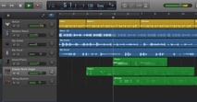  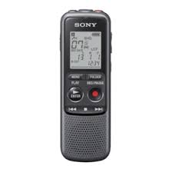      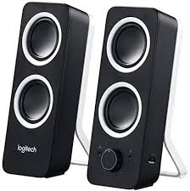  Garageband  iPad  cd player  Voice recorder  keyboard  speakers  Microphone  YouTube
  To suggest and control changes to performances and compositions by using the opposites (faster/slower, louder/quieter, higher/lower) | To perform simple accompaniments (including use of rhythmic ostinato) to a melody and give thought to the meaning / mood | To choose sounds to represent ideas (e.g. shakers for leaves falling off a tree)
  To create and perform simple melodies using two tones on a tuned instrument | To compose in a small group with other children

